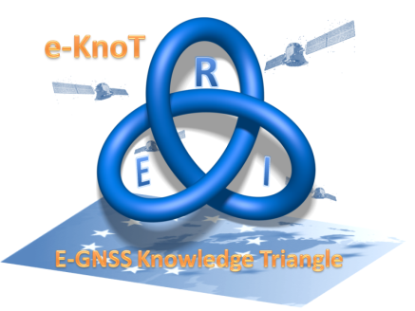
e-GNSS Knowledge Triangle

COMPANY EXPRESSION OF INTEREST FOR CONSULTANCY VOUCHERS

FIRST PAGE
INFORMATION RELATED TO THE COMPANY
Name-address of the company
Short description of the company’s activities. Web Site: 5 lines
Name of the unique representative of the company for this call:
- Role in the company
- Email address
- Telephone

Date and signature

Participation to the call implies that the Required Expression of interest for the “industry voucher” is fulfilled and signed, the Terms and conditions agreed and signed, both documents has to be sent to vouchers@eknotproject.eu before
September 15, 2017 - midnight (CET)
Documents provided later will not be considered.

SECOND PAGE (Texts in italic can be suppressed in the submitted document)
DESCRIPTION OF THE CONTEXT: (HALF A PAGE)
Please describe the context allowing to understand the request: description of the device, the process…on which the company is working, the environment of the activity ….Develop in particular the role and added value of GNSS.
TEXT TEXT TEXT

DESCRIPTION OF THE TOPIC: (HALF A PAGE)
Please describe precisely the topic for which the company would like to benefit from the Consultancy voucher. Explain the originality of the idea, in which way the consultancy will bring to the company, what are the issues to be assessed etc…
This part of the Expression of interest combined with the understanding of the context will be assessed under criteria 1 based on the clarity of the request, soundness of the idea and support expected from the consultancy

TEXT TEXT TEXT

THIRD AND LAST PAGE
INTEREST FOR THE COMPANY: (HALF A PAGE)
Please indicate how, based on the description provided above, the expected Consultancy would bring an added value to the company as well as the innovation expected in the short and medium term .Explain the impact expected from the work.
This part of the Expression of interest, combined with the next one (implementation of the idea) will be assessed under criteria 2 based on the evidence that the joint effort for the Consultancy is worthwhile rom both an innovative an the introduction in the market .

TEXT TEXT TEXT

IMPLEMENTATION OF THE IDEA: (HALF A PAGE)
Please indicate what is the Implementation expected for the topic. In particular the feasibility of the Topic after that Consultancy, how close to the market is the idea. A simple risk analysis and possible budget considerations for the company (investment, cost benefits …) close to market etc.)

TEXT TEXT TEXT

End of Document

